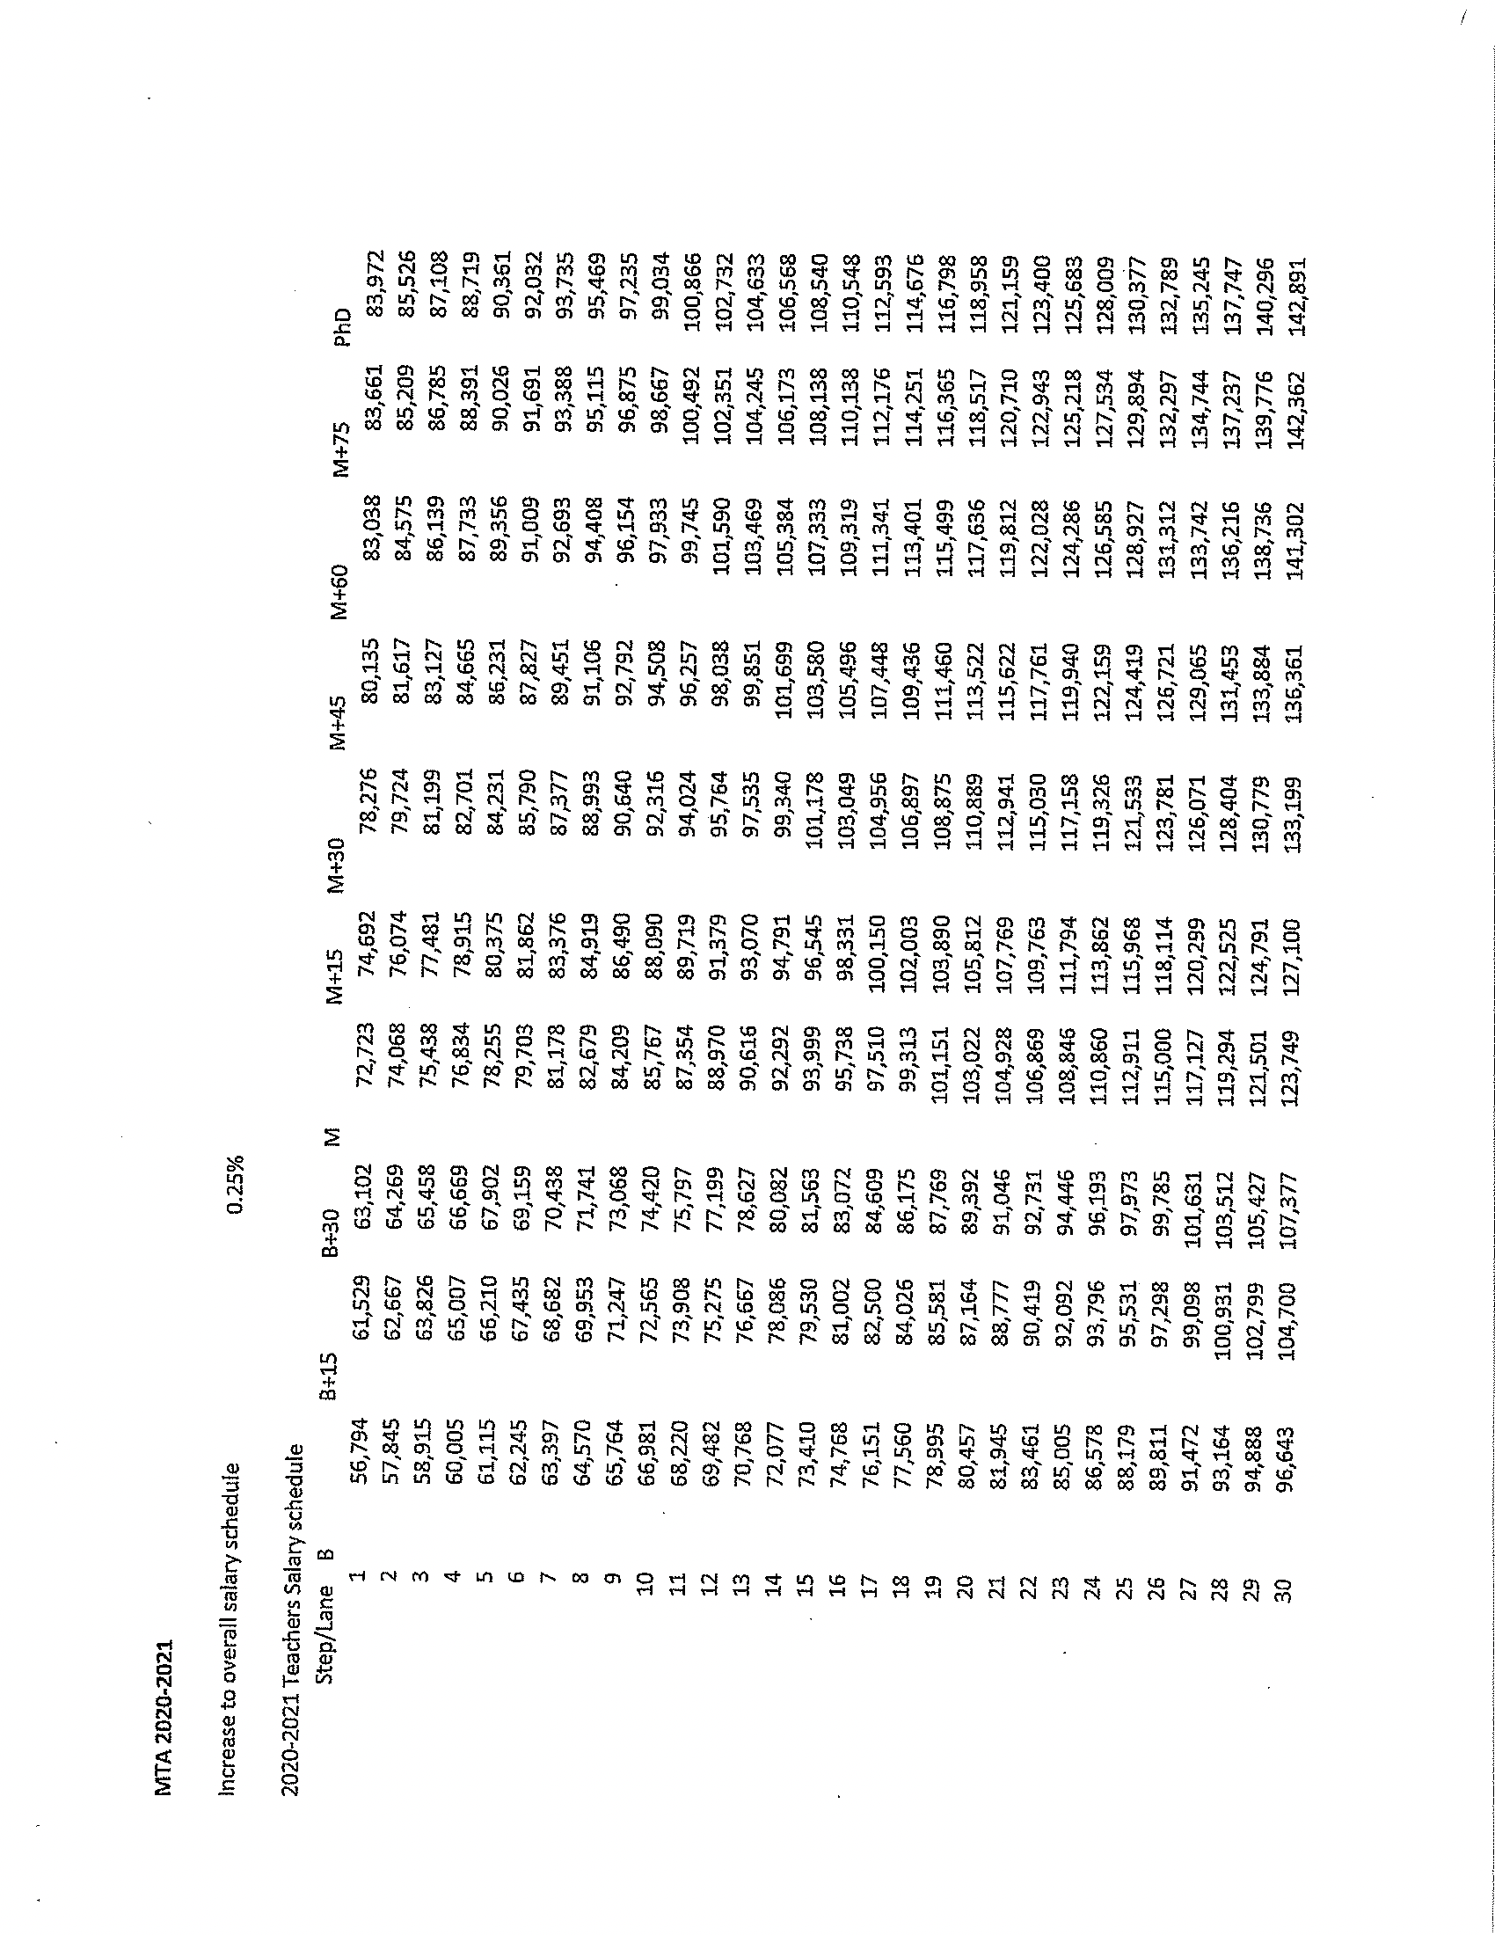

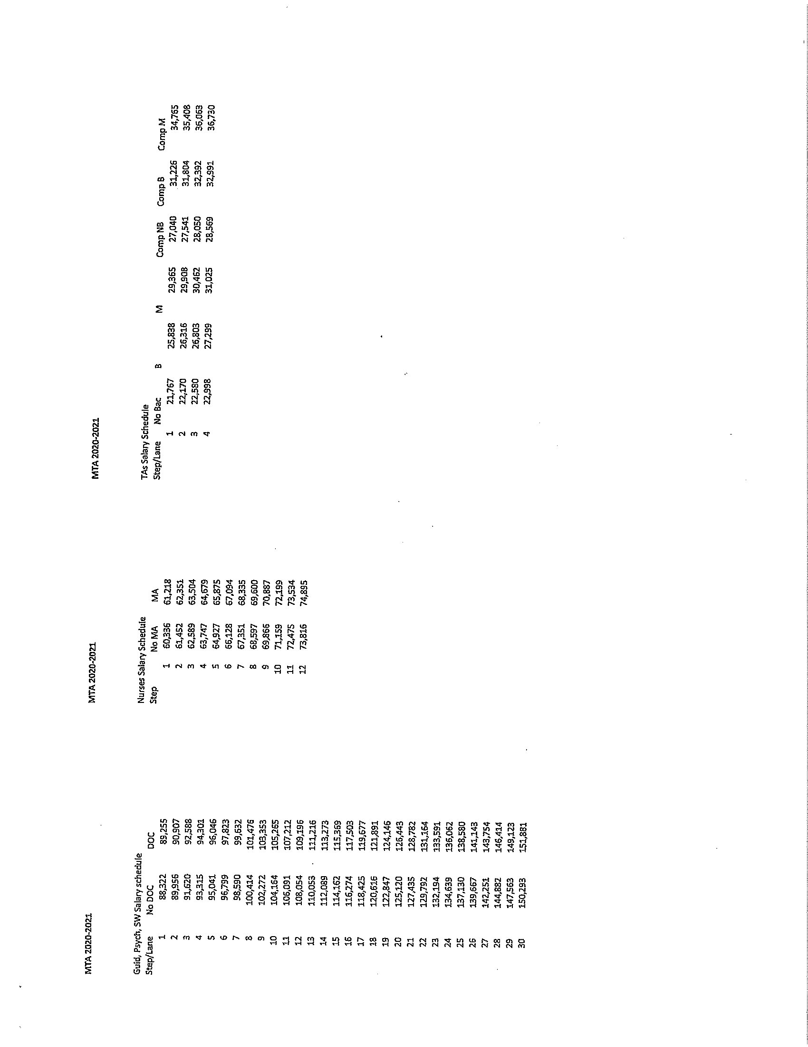

2020-2021 LONGEVITY SCHEDULE - TEACHERS
Mamaroneck Teachers' Association
Years of Service | Hired PRIOR to 7/1/98 | Hired on or AFTER 7/1/98
18.0 | $4,463.00 | N/A
21.0 | $9,404.00 | $2,700.00
24.0 | N/A | $5,400.00
26.0 | $14,941.00 | N/A
27.0 | N/A | $8,100.00
30.0 | $19,029.00 | $10,800.00

2020-2021 LONGEVITY SCHEDULE
Mamaroneck Teachers' Association
Years of Service | Nurses | Teaching Assistants
5 | N/A | $1,000
10 | N/A | $1,000
15 | $1,248.00 | $1,000
20 | $1,248.00 | N/A
25 | $1,248.00 | N/A

